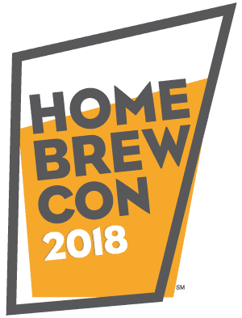
Volunteer Information & Handbook

About The Conference
Homebrew Con is the ultimate experience for anyone interested in homebrewing and understanding beer, mead and cider. With dozens of sessions for every interest, a homebrew expo to rule them all, and the legendary Club Night, Homebrew Con is sure to become your annual pilgrimage along with over 2,000+ of your new best friends.
www.homebrewcon.org
2018 Host Venue
American Homebrewers Association
The American Homebrewers Association has worked on behalf of the homebrewing community since 1978 and celebrates a membership of more than 46,000 homebrewers and beer enthusiasts. The American Homebrewers Association (AHA) also publishes Zymurgy magazine. The AHA is a division of the Brewers Association, based out of Boulder, CO.

Homebrew Con 2018 will take place at:
Oregon Convention Center
777 NE Martin Luther King Jr Blvd
Portland, OR 97232
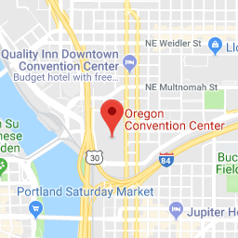
How to Volunteer at Homebrew Con

• Volunteers are needed to pour at both the Welcome Reception and many of the Seminars. All volunteers must be registered event attendees.

• Homebrew Con attracts people from other towns, states, and countries. You are an ambassador to our guests, the face of the American Homebrewers Association and the Brewers Association, and we ask you to be friendly, professional, polite, and helpful to everyone.

• Check in at the Volunteer Office (TBD) 15-20 minutes before your assignment. Volunteers are asked to participate in a brief training prior to each shift.

• Be easily recognized by wearing the official Homebrew Con volunteer shirt. Your volunteer t-shirt is your uniform! You will receive an event t-shirt when you check in for your first shift; please wear it for all subsequent shifts.

• Have a pleasant demeanor and a commitment to representing the American Homebrewers Association, Brewers Association and Homebrew Con in a positive manner.

• Upon arriving for your shift, please introduce yourself to your shift supervisor and clarify what your roles and responsibilities will be. Report to your shift supervisor when completing your shift and when going to or returning from a break.

• Please greet our attendees with a smile and the attitude that “the customer is always right.” If you must say “no” to someone, do it with a positive attitude! If there is a question you cannot answer, don’t guess. Please get your supervisor or a member of the event staff who can provide the correct information.

• If there is a situation where an attendee is unhappy, and continues to be unhappy, please get your supervisor or a member of the event staff.

• Homebrew Con and your fellow volunteers rely on your presence at each shift you sign up for; we're counting on you so please don't be a no-show. If you cannot meet your commitment on an assigned day, please give us as much notice as possible so they can find a replacement volunteer.

• Smile! Laugh! Have fun! It’s Homebrew Con!

Volunteer Rules and Responsibilities

• Your main duty as a volunteer, next to your assigned area, is to offer assistance and information to our guests. Please be courteous and helpful to all participants. Offer any special assistance to those with special needs.

• If you taste while working, we expect that you adhere to our policy of TASTING BEER CONSERVATIVELY.

• Volunteers MAY NOT (under any circumstances) over indulge. Over indulgence on site (or the appearance or suggestion of over indulgence) will result in immediate removal from your position.

• Please do NOT touch the pitcher to the lip of the guest’s cup. This is one of the biggest ways people get sick. Instead, ask the patron to put their cup on the table and then pour beer.

• Please, no personal calls, texts or cell phone use while volunteering.

Other Event Rules and Policies

• Everyone is welcome at Homebrew Con, regardless of age, dress, haircut or personal style. The only requirement is that our guests must treat each other with respect.

• No smoking of any kind or consumption marijuana is permitted while working shifts at the event or while wearing an event volunteer t-shirt. If you must smoke tobacco during your volunteer shift, please find a smoking area away from your volunteer location.

• Remember, anytime you are wearing your t-shirt, you represent Homebrew Con. Please honor our policies and expectations; volunteers may be dismissed if they are in violation of them.

• All packages are subject to search.

How Do I Handle These Issues?

• Medical or security emergencies?
• Lost and Found?
• Media inquires?

Contacts
Carol Hiller, Volunteer Manager
303-668-2322

Homebrew Con Volunteer Acknowledgement

By requesting to participate as a volunteer at Homebrew Con, you agree to the following:
• Completing an application does not guarantee a volunteer position with the Conference.

• The Conference does not cover you in case of injury or illness.

• You will receive no compensation for your donation of time for the activities performed before, during or after Homebrew Con.

THANK YOU TO OUR AMAZING VOLUNTEERS!

